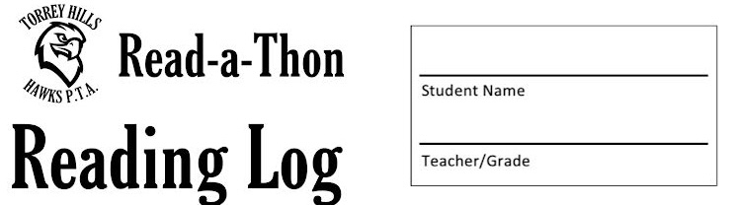***Have your parent/guardian sign your form after you’ve read each night. Bring your form to school each day.***

**My overall reading goal is to read _________________ during the Read-a-Thon.**

**In order to reach my goal, my personal goal is to read ___________________ minutes each day.**

|  |  |  |  |  |  |
| --- | --- | --- | --- | --- | --- |
| **Day** | **# of minutes read at school** | **# of minutes read at home** | **Total # of minutes** | **Parent Signature** | **Running Total of Minutes** |
| 9/16 |  |  |  |  |  |
| ***\*\*Bonus Reading on the Weekend*** |  |  |  |  |  |
| 9/19 |  |  |  |  |  |
| 9/20 |  |  |  |  |  |
| 9/21 |  |  |  |  |  |
| 9/22 |  |  |  |  |  |
| **TOTAL** |  |  |  |  |  |